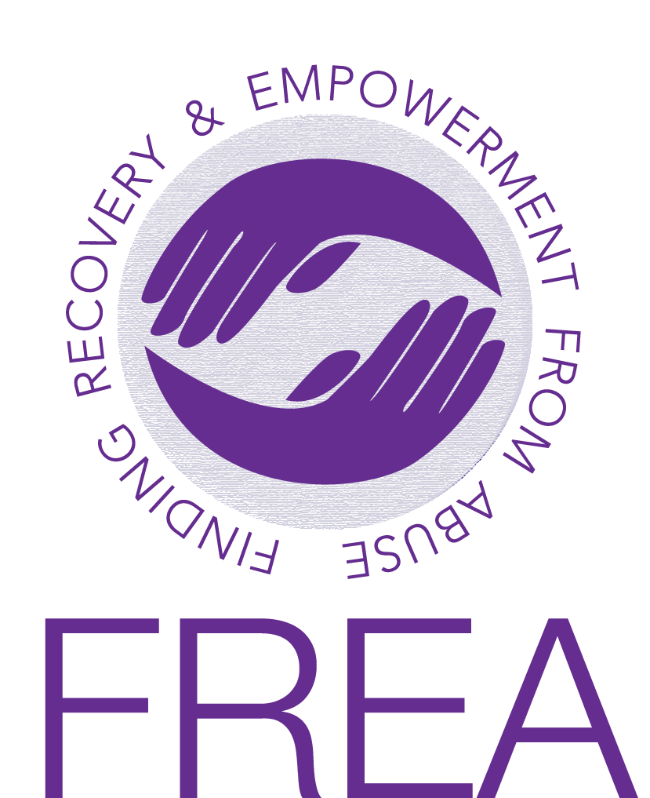

THE FREA Committee

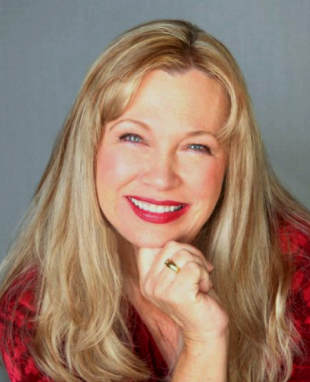
Robin Trainor, FREA’s founder, received a BA degree from Baldwin Wallace University, and a Masters degree in Counseling and Family Relations at Ohio State University, followed by post graduate training at the University of Pennsylvania School of Psychiatry Marriage Council. Having a family history of addiction, after graduation she developed programs for children of alcoholics and therapeutic interventions for adult children and sexual trauma survivors.
For the past 38 years she has specialized in treating trauma and sexual abuse, and has presented her work at numerous trainings and conferences. She believes that many trauma survivors are spiritually evolved, and she assists them in discovering and recovering the Gifts of their trauma.
Robin is the mother of four grown children, and grandmother of eight. She, her partner Gary and her family continue to practice energetic techniques for self-healing. Knowing their value first-hand, she has a passion to share these techniques with others. FREA is the result of her Vision to assist and support others in their Journey to Healing.

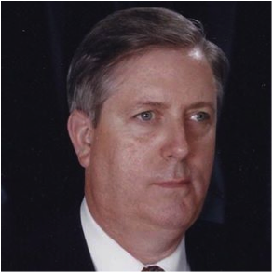
Stephen W. Carter, MA, has been helping people master stress and create healthier, happier lives for more than four decades. As a former police trainer and chief of police, he was in the forefront of creating innovative stress reduction programs for crime victims to include victims of sexual assault, law enforcement officers, and other public safety officials.
As the Corporate Security Director for a major financial services corporation, he developed and taught stress mastery methods to help ensure employees and executives successfully handled bank robbery, kidnap / hostage situations, and other high-stress traumatic experiences.
In recent years, Steve has worked directly with clients through his company, Stress Solutions, LLC, to help them create empowering and successful lives. He is a licensed trainer for the Association for Meridian and Energy Therapies where he teaches Emotional Freedom Techniques (EFT) and other stress mastery methods. He is a Master Neuro-Linguistic Programming (NLP) practitioner, hypnotist with an emphasis in Ericksonian methods, and a certified Thought Field Therapy (TFT) practitioner.
www.eft-md.com

ANGELA CLARK says: “I'm a survivor of incest, sex trafficking, and rape. I'm on a mission to help us break the cycle of silence and reach beyond the pain. Our past does not define our future - we have choices, healing is possible. My emphasis is on practical tools and education in regard to our thoughts and feelings. Healing happens through one-on-one connection, community, and hope. My book The Other F Word: My Manual on Forgiveness, is coming out in 2018. I'm a Life Coach specializing in reclaiming your voice and rebuilding confidence during recovery with a focus on self-care practices, boundaries, and defining what's next in business and relationships.
I enjoy Dances of Universal Peace, hiking, and adventures in the wild. I have 2 adult children who constantly inspire me. I love my Life ----- and I want other survivors to know they can thrive too.”
www.Iamangela.org

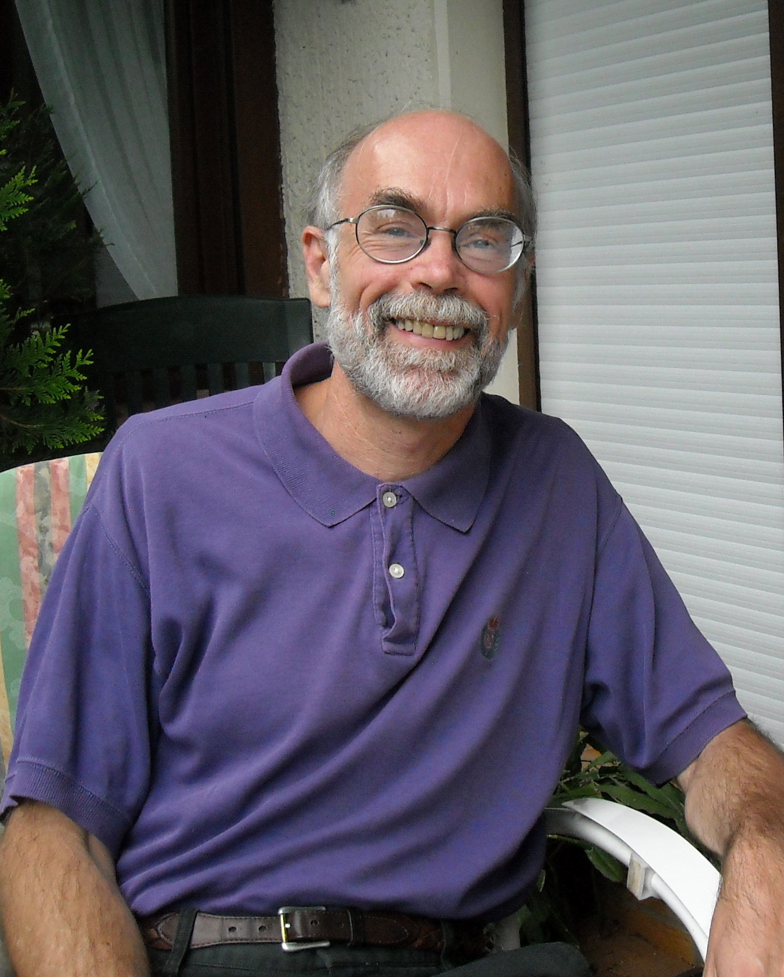
John Freedom is a counselor, educator and trainer in private practice in Santa Rosa, California.
The author of Heal Yourself with Emotional Freedom Technique, he serves as research coordinator for ACEP, the Association for Comprehensive Energy Psychology; on the Board of Trustees for AAMET, The Association for the Advancement of Meridian Energy Therapies; and program coordinator for FREA, Finding Recovery and Empowerment from Abuse. He holds certifications in EFT, NLP, EMDR and auricular acupuncture, and specializes in helping people experience greater success, happiness and high-level wellness.
A former radio talk-show host and magazine editor, he leads seminars and trainings throughout the US and in Europe. As a survivor himself, he brings an awareness and understanding of these issues to the challenges that survivors of sexual abuse face.

LYNDA FREEMAN: “ I started my working life as a secretary. Some years later, whilst working in the Training Department for a UK Bank, I discovered my love for coaching, so completed a Diploma in Life and Performance Coaching.
Wanting to see more of what life was really like, I trained to work as a relief support worker with people and children with Learning disabilities and severe autism. I was also assigned to work as a support worker for a women’s refuge (shelter). I loved it so much I still work there.
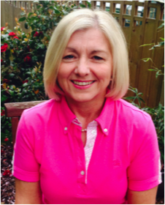
During this time, I was coaching in a women’s prison as part of a project that successfully reduced the re-offending rate. I then took the coaching into the refuge (shelter), which was well received. Women arrive at the shelter after fleeing their perpetrator, often with little or no personal belongings. Emotionally and physically traumatised, they have little hope and little self-identity.
I developed a programme of self-discovery, which the women report to be a valuable insight into regaining their sense of ‘self’ and hope that there is a brighter future for them. I have now taken this into other refuges in the area. During the coaching sessions, I draw on all my different skills, which include NLP Practitioner, Clean Language Coach, and AAMET Certified Practitioner.

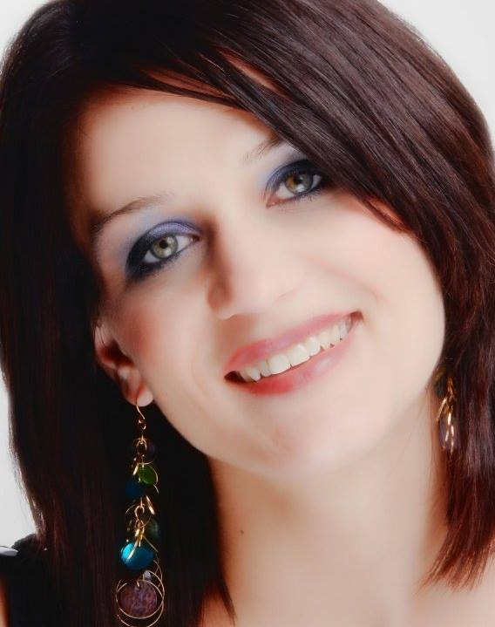
Katey Gula lives in Canton, Ohio with her son, daughter and two dogs. She writes “…. Between my son’s passion of digging for worms and my daughter's desire to turn me into a taxi cab driver, we live an eventful life. I am a woman of many abilities and never could decide what I wanted to be when I grew up. In 2007, I graduated with an Associates degree in Interactive Media focusing in video production. After graduation I began a series of freelance projects ranging from creative dance pieces to local music shows.
In 2010 a series of events changed the trajectory of my life, and I began a soul searching era. During that time, I went back to undergraduate college, and graduated from Malone University with a bachelor of arts in marketing management. Ultimately, through prayer, meditation, and some guided hands, I entered into the psychology field as a Mental Health Case Manager. I have been professionally serving my surrounding communities for two years. I have experienced great joy in helping others, and have experienced great fatigue. My passion for aiding others around me keeps me fuelled to continue my academic aspirations in order to proficiently help others at a prolific level. I was introduced to FREA In 2015, and found these techniques are capable of doing just that. Once trained and certified in TTT Trauma tapping, I began to share this gift of healing with those around me. I am grateful to be a part of a community of people with such compassion, understanding, and desire to aid others to freedom.”

GUNILLA HAMNE is a former journalist, a trauma therapist, and humanitarian activist working with refugees and children’s rights. Together with her partner Ulf Sandstrom she developed the Trauma Tapping Technique (TTT), a simplified language and content free tapping modality. They focus their humanitarian work through their foundation, The Peaceful Heart Network, and are estimated to have reached over 100,000 traumatized people. They have organized humanitarian projects in Rwanda, Congo, South Canada, and other parts of Africa as well as in India, Europe, Canada and the US.
www.peacefulheart.se

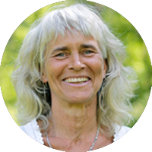

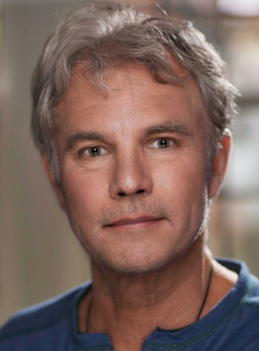
Eric Huurre brings four decades of producing, directing and marketing expertise to his work as a multidisciplinary filmmaker and more recently to energy therapy training and public awareness media creation. Additionally, he is an AAMET-certified EFT life coach.
Working from a core belief that the human story is a critical aspect of effective communications and learning, Eric forms strategic alliances to produce and deliver social-issue programming specializing in health and wellness seen from the subject’s own perspective, needs and advantage.
His feature-length documentary OPERATION: Emotional Freedom — The Answer has brought awareness of EFT for the treatment of PTSD to combat veterans and caregivers around the world. Eric’s commitment to producing positive-impact, public information programming, extends through his film, video and internet work for: National Geographic Explorer; Discovery Channel; Outdoor Life Network; CBC; Channel 4; YTV; Disney Channel and many other broadcasters and webcasters internationally. His work in support of energy therapies for young people includes: tapping4kids.international; The Oaxaca Project; and Project Light Rwanda.
www.eft4kids.org www.operation-emotionalfreedom.com

KRISTIN MILLER, PhD. I am a traditionally trained California Licensed Psychologist with a Diplomat in Comprehensive Energy Psychology, a TFT Humanitarian Trainer, certified in Matrix Re-imprinting, a certified EMDR Therapist since 1990, and a Behavioral Pain Specialist, along with lengthy informal training and teaching experience in the use of meditation and spiritual techniques to heal trauma and soul issues.
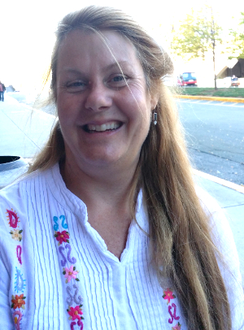

I specialized in the treatment of comprehensive, intergenerational, developmental, and health trauma. Frustrated with the lack of depth of cognitive behavioral therapy and the retraumatizing effect of lengthy EMDR sessions, I retrained in Energy Psychology in 2006. My clients are delighted with the ability to reach the nonverbal core of trauma, empowered by self-administered skills that rapidly shift the energy field to support a compassionate healthy existence.
I actively serve on the Humanitarian Committee and Resources For Resilience project for The Association of Comprehensive Energy Psychology.

DR. ADRIANA POPESCU is a licensed clinical psychologist and transformational life coach with over 20 years of experience in the mental health field. She received her M.A. and Ph.D. from the Institute of Transpersonal Psychology, a program that takes a holistic approach to the training of psychotherapists, teaching them how to help clients self-actualize and reach their highest human potential.
Adriana is also a certified hypnotherapist, Access Consciousness Facilitator, and Neuro Emotional Technique (NET) Practitioner, having discovered that Energy Psychology provides incredibly powerful tools to identify and eliminate the deep-rooted causes of suffering and distress. She developed her specialty in treating addictions and co-occurring disorders over fourteen years at Catholic Charities of Santa Clara County, where she managed the Adult Substance Abuse Program, as Director of Outpatient Services at Marin Services for Women, and Director of Outpatient Services at Alta Mira Recovery Programs.
She is currently in private practice in San Francisco and travels around the world coaching and facilitating transformational and empowering workshops.
www.adrianapopescu.org

Juli Steinocher, MA, LMHC, lives in St Petersburg FL with her husband (best friend), two boys, and a free roaming neighborhood cat. She grew up in Indiana and graduated with a marketing degree from Indiana University. She attended graduate school at the University of South Florida and became a licensed mental health counselor.
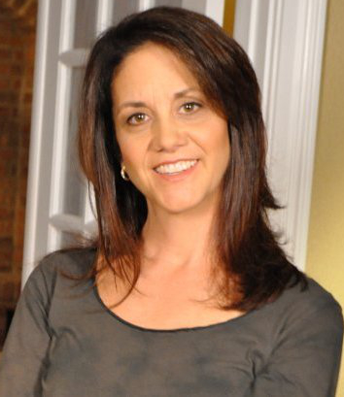
In 2005 she was introduced to Energy Medicine and extensively studied the energy systems in the body. She then became a licensed massage therapist and learned ways to incorporate the body to release emotional upsets and traumas. In 2009 she launched a practice called mindbodylab.com with focus on treating the whole person and guiding clients wanting to be the hero in their life’s story rather than a victim of trauma or abuse. Her passion is providing simple and effective tools for dissolving upsets so clients can feel peace.
She has assisted war veterans, and survivors of domestic violence, molestation, rape, assault among other traumas. Her passion is providing simple and effective tools for resolving upsets so people can become all they were meant to be.
www.mindbodylab.com
ULF SANDSTROM is a musician, hypnotherapist and humanitarian activist in Stockholm. Together with his partner Gunilla Hamne they developed the Trauma Tapping Technique (TTT) - a simplified, language and content free tapping modality. TTT is designed for non-specialist scaling and is estimated to have reached over 100. 000 people in challenged areas around the world through trainings sponsored by their organization, the Peaceful Heart Network. They continue to do humanitarian outreach in Rwanda, Congo, South Sudan, and other parts of Africa as well as in India, Europe and the US and Canada. www.peacefulheart.se

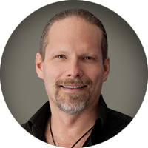
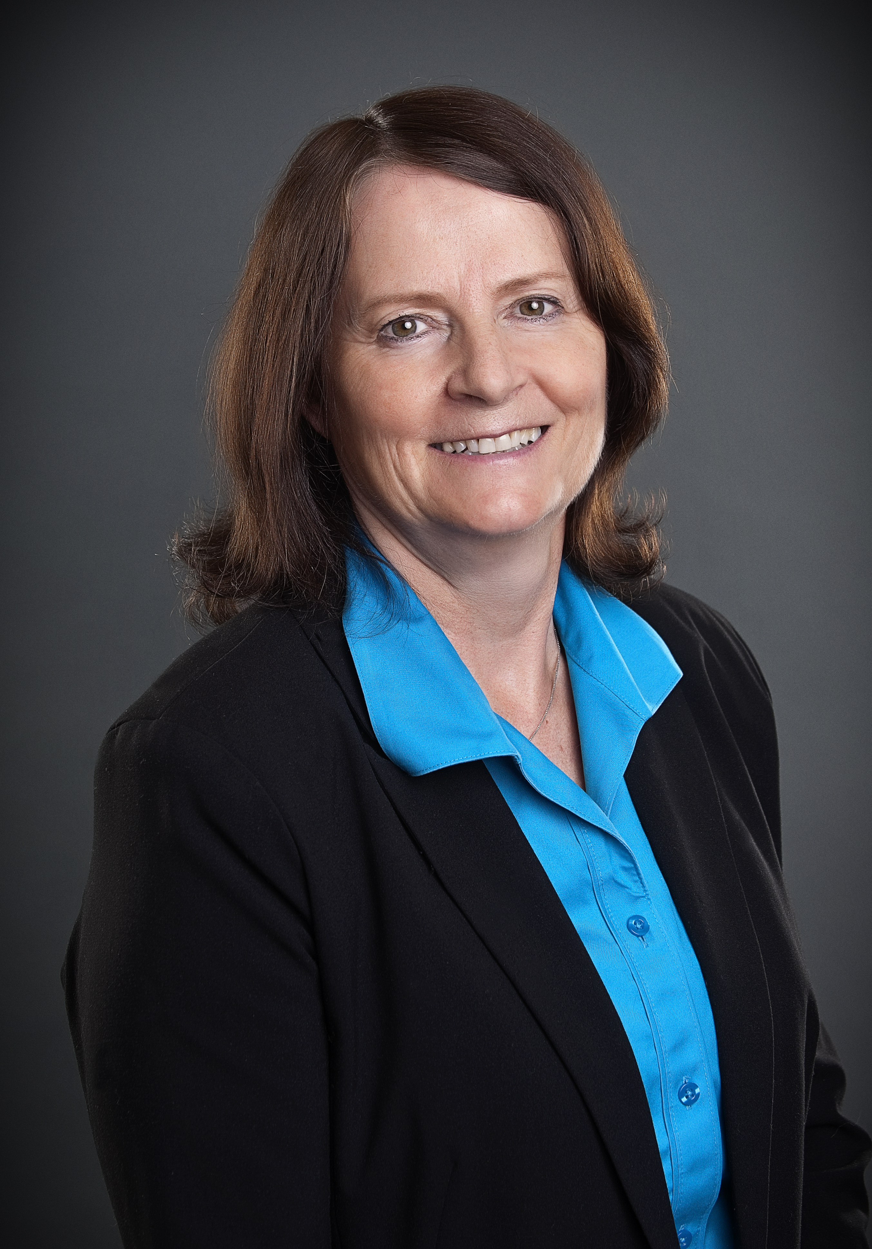
LINDA IRVINE SAPIANO: “ I received my B.A. degree in 1975 from Queens University, my law degree in 1978 and was called to the Bar in 1980. I have been a lawyer for over 37 years, practicing predominantly in the area of family law. For most of my career, I have focused on avoiding court litigation and working on reaching settlements. I am a founding member of the Ontario Collaborative Law Association as one of the first lawyers to bring this new way of resolving conflicts to Canada.
For many years, I was on the Board of Directors for Chedoke-McMaster, a teaching hospital associated with McMaster University Hospital Medical School. I am interested in helping people recover from sexual abuse and trauma. I have seen first-hand the effects of sexual abuse and domestic violence on people and their families when this happens to them. I have a long term interest in working with survivors to help them achieve full, happy and productive lives. I have joined FREA as it is a positive force of healing for people who are survivors of abuse on their journey to recovery.”
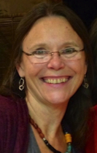
HOLLY TIMBERLAKE, PhD is a licensed psychologist with a Diplomate in Energy Psychology. A survivor of early childhood trauma, she has extensive experience as a trauma therapist, using Energy Psychology, guided imagery, Gestalt & cognitive-behavioral methods. More recently she has incorporated attachment and developmental trauma therapies into her work with adults with PTSD and abuse/neglect histories.
Dr. Timberlake was the founder in 2003 of Nakaia Healing Arts, one of the first holistic wellness centers in Northeast Ohio. The creator of Tapping into the FieldTM, guided, emotional healing meditations, she also trains people in the use of EFT/tapping for self-healing and has presented internationally on topics of Energy Psychology, holistic living and unified field psychology. She is beginning a certification program for body/energy practitioners to incorporate tapping methods into sessions when clients access powerful emotions. She has taught courses & created workshops at undergraduate and graduate levels and a director for an organization charged with reducing racism within communities. She lives in the vibrantly creative community of Akron, Ohio with her grown family close by. She’s a nature, art, music and dance enthusiast, and is grateful for radical aliveness and loving connections.
www.nakaia.org

